Jacob Ciurca

Dr. Park

Lab 6

Cosc 350

10/26/2020

Run fork1.c with values of 5 3 1 5 then 5 3 5 1

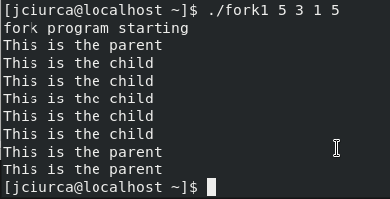

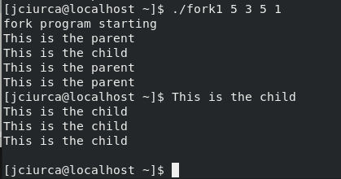

Run forkwait.c with 5 3 1 1 and compare output to fork1.c

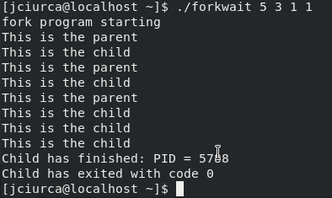

This output differs from fork1.c in that forkwait doesn’t bring you back to the command line until the child function ends even though the parent function already ends. The fork1.c command brings you back to the command line as if the program is over once the parent function ends even if the child function has not yet finished.

Forkfile.c finished example. Creates files of child.txt and parent.txt

